[IMA-1] Uninstall the app gives me a message that my data will be deleted but it´s still saved when you install the app again Created: 08/Sep/24 Updated: 09/Sep/24
Status: | To Do
Project: | Instagram Mobile App

Type: | Bug | Priority: | Medium
Reporter: | Tomer Darmon | Assignee: | Unassigned
Environment: | OS : Android  Device : One Plus 11 5G OS Version : Android 14

Attachments: | 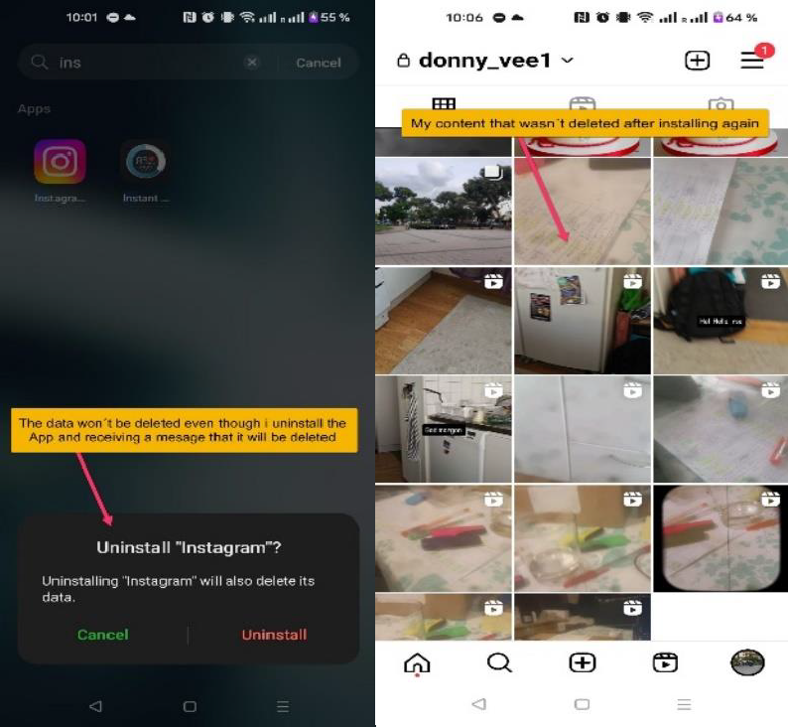
Severity1: | S3 - Major

Description
Steps to Reproduce:
- After launching the "Instagram" app press on its icon on your home screen or in the app drawer
- Press and hold the icon and tap on "Uninstall" and then "Ok"
- Enter the Google app store and download the "Instagram" app again
- Launched the app and write your username that you registered before with the same password
- Enter to your profile and check the posts, Stories, Reels and tags
Actual Result:
After uninstalling the app and receiving a message that my data would be deleted, Instagram shows all my posts, stories, reels, and tags after reinstalling
Expected Result:
I will expect that after uninstalling the "Instagram" app from my device and re-installing it back again, the app won´t remember my account and i won´t be able to see my previous data

20

